T3 DQ2

For Major Assignment 2 in Topic 4, you will look ahead at your financial plan after graduation. For this DQ, you will look ahead at the assignment instructions and take some time to think about what you will need to do for this assignment.
Start by reviewing the instructions for Major Assignment 2. There is a template for the written portion and an Excel template in the Topic 4 tab in Halo. (See below.)
For this DQ, complete the following three items using the template for the written portion of Major Assignment 2 (see below) and upload your work as usual to the DQ forum.
Note that each of the following only covers a part of what is asked in the actual write-up for Major Assignment 2; this DQ is getting you started in the right direction, but this is not a completed write-up. Make sure to provide your responses in well-written paragraphs, not in lists. Do not cut and paste from an AI.
Your response needs to be submitted on the template for Major Assignment 2 (see below), not on this sheet.

Income and Projection

- Considering real-world expenses upon graduation, what careers in your program of study are likely to provide enough net income to cover these expenses? Here, you may want to give a broad estimate of your expected monthly or yearly expenses, along with a broad salary estimate. Remember also to think about the effect of taxes on your net income.

Student Loans
- Assume that you’re taking a student loan of $50,000 at an interest rate of 8%, and that you will start paying that loan back in 4 years. Explain why it will always be the case that if your loan is subsidized, your loan payment will be lower than if your loan is unsubsidized, assuming that the interest rate in the unsubsidized case is the same and that interest accrues for the 4 years that you’re in school. (You’re welcome, but not required, to provide calculations to support your explanation.)
References
Find three academic sources that provide information on the impacts of debt on personal spending and the global economy. References must be in APA style.
For example:
For a Book:
Author, A. A. (Year). Title of book (Edition if applicable). Publisher.
For a Journal Article:
Author, A. A., & Author, B. B. (Year). Title of the article. Journal Name, Volume(Issue), Page numbers. https://doi.org/xxxx
For a Website:
Author, A. A. (Year, Month Date). Title of the webpage. Website Name. URL
For an AI Model (e.g., ChatGPT):
OpenAI. (Year). Title of the AI model (version) [Large language model]. Company Name. URL

Note: You are asked to do a bit more for these sections in Major Assignment 2; you may complete the full instructions if you would like, but the three questions asked above suffice for this DQ.
You can find the Major Assignment 2 template for the written portion under Topic 4 in Halo:
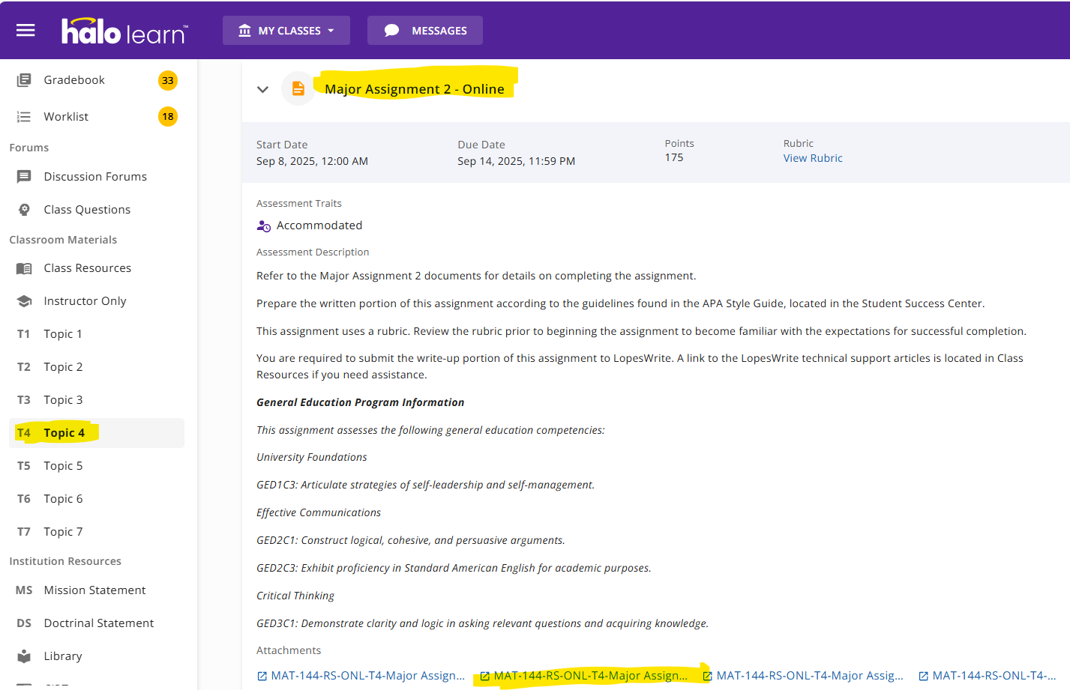
The template is named MAT-144-RS-ONL-T4-Major Assignment 2 Write-up Template Online 20250317.docx and looks like:

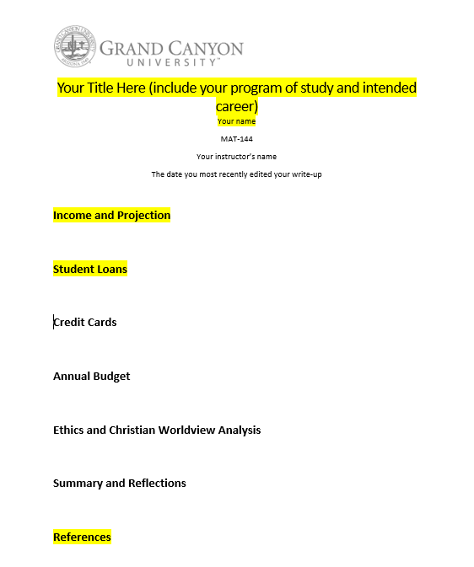
This is what the template looks like. For this assignment, you need to complete the highlighted parts as described above.

